**Problem Statement**

Merge the small files in hadoop by following the below blog.

<https://acadgild.com/blog/merging-files-hdfs/>

**Solution:**

**Steps to merge the files**

***Step 1:***

Place more than 1 file inside the HDFS directory.

There are three files named test1, test2 and test3 on which we will perform merging operation.

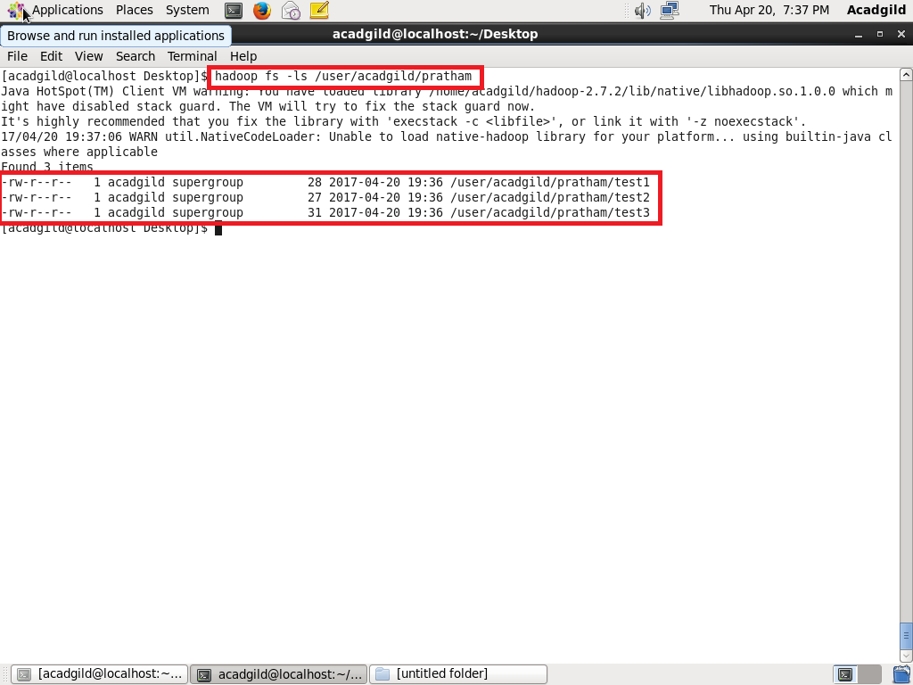

The content of the files is shown in the below screenshot.

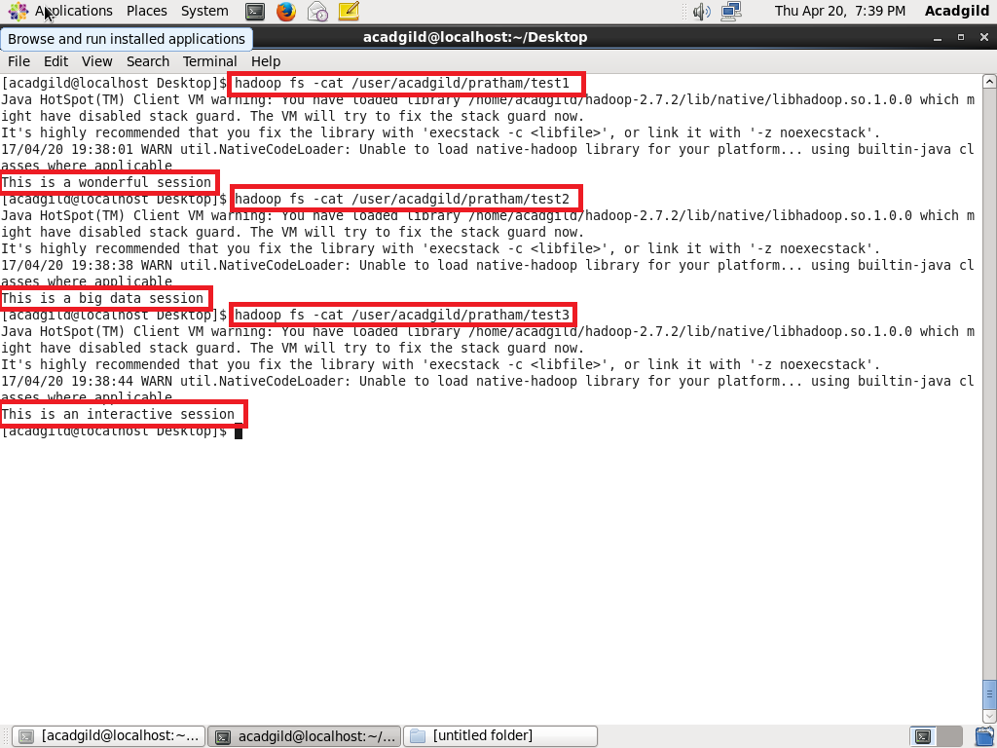

***Step 2:***

Type the command as shown in the screenshot, to merge the files.

We have used -nl as an optional parameter to add extra line after the content of each file.

File will be created in a specific location of your local machine with merged content. In this case, a new file with the name **save.txt** will be created, having the content from test1, test2 and test3.

Directly open the file to see the merged content.

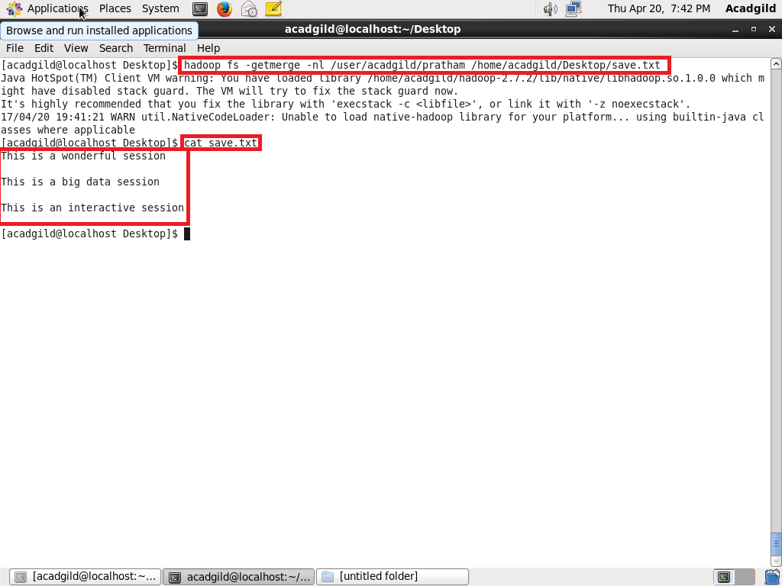

 File is created after merging the content of three individual files.